My health and wellbeing in prison and beyond 2 (men)

Unit 1
Health and Hygiene

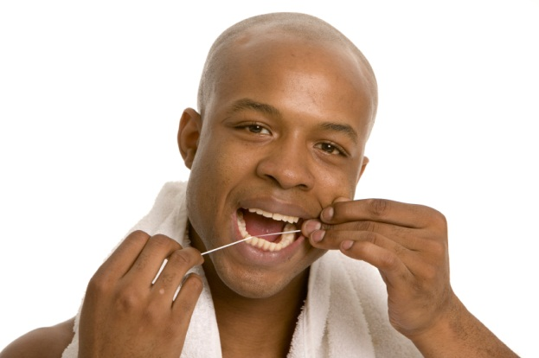

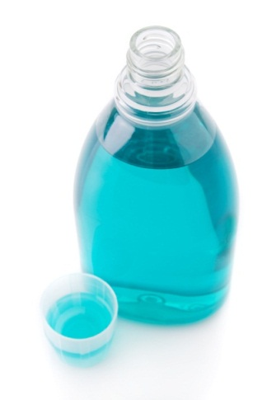

Contents

Unit 1 Health and hygiene in prison: teacher’s notes

Unit 1 Health and hygiene in prison: learner resources

Unit 1 Health and hygiene in prison: answers and transcript

Unit 1 Health and hygiene in prison: Ravis_Order.mp3

Unit 2 Mental health: teacher’s notes

Unit 2 Mental health: learner resources

Unit 2 Mental health: answers and transcript

Unit 2 Mental health: Video Becoming a Listener

Unit 3 Living with addiction teachers’ notes

Unit 3 Living with addiction learner resources

Unit 3 Living with addiction answers

Unit 3 Living with addiction video file

Copyright - please read
All the materials on these pages are free for you to download and copy for educational use only in your establishment. You may not redistribute, sell or place these materials on any other website without written permission from the British Council. If you have any questions about the use of these materials please email us at: esolnexus@britishcouncil.org

Unit 1 Health and hygiene in prison: teacher’s notes
This unit focuses on personal hygiene in prison and its connection to health and well-being. The materials include vocabulary activities based on the toiletries section of a canteen sheet for ordering things in prison. There is a listening activity of a prisoner speaking about what he wants to order in his weekly shop in prison. The unit provides learners with language to order toiletries and thereby increase awareness of good personal hygiene.

Level: Entry level 1-3 / Access 2 – National 4 / CEFR A1 - B1

Time: Approximately 90 minutes.

Aims
- To develop listening skills
- To build confidence reading for detail in the context of looking for items on a canteen sheet
- To introduce lexis associated with personal hygiene
- To practise using adverbs of frequency

Objectives
Entry 1 and 2 / National 2 and 3 learners will be able to:
- Name toiletry items
- Use the present continuous
- Listen to and understand a prisoner’s toiletry order
- Read and understand some words for toiletry items on a typical canteen sheet
- Complete an exercise using adverbs of frequency
Learners at higher levels will be able to:
- Listen to and understand further details about a prisoner’s toiletry order
- Write personal sentences using adverbs of frequency
Preparation
You will need:
- Resource 1: toiletry items. There are two versions of the resource: version 1 has been designed to be cut up so that learners can match the words and images; version 2 is on one page and can be labelled if you want to minimise printing.
- Resource 2: to save photocopying, you could ask learners to copy the information.
- Ravi’s order audio and device to play it on.
- A copy of the canteen sheet used in your institution (if obtainable).
- Toiletry containers for the cooler activity (if possible).
Suggested Procedure
Warmer: What are they doing? (5 minutes)
- Show the pictures to the class (on the resource or a whiteboard). Ask learners to describe what the men are doing.
- Elicit the statements from learners using the present continuous; for example, he’s having a shower and washing his hair.
- Tell the learners that the lesson will focus on things we need to keep clean in prison.
Differentiation: You may need to revise the present continuous form for lower level learners. If needed, take each picture and elicit the present continuous statement, writing it on the board. Emphasise the -ing form and check learners understand that it relates to something happening now or at the time of speaking.

Activity 1: Vocabulary – name the toiletry items (10 minutes)
- Lead in to this activity by eliciting various toiletries from learners. For example, you could mime the action and ask:
What do you use to brush your teeth? (a toothbrush, toothpaste)
What do you use to shave? (a razor, blades, shaving gel/cream).
- Teach the toiletry items using resource 1.
- Check the items with the learners and drill pronunciation as required.
Differentiation: Give low-level learners version 1 of resource 1 to match the cut-up words and pictures; ask more confident learners to spell the items directly on to the resource (version 2).

Activity 2: Vocabulary – categorising toiletries and spelling practice (10 minutes)
- Consolidate learners’ understanding by asking them to sort the toiletries according to where you use them. Using resource 2, ask them to write the items in the box under teeth, body, hair or other.
Tip: To save photocopying, you could ask the learners to copy the table on resource 2 (which you could display) on to a blank sheet of paper and fill in the items.

- After categorising the words, nominate learners to spell the toiletries. You could describe the word first (for example, ‘you use this to brush your teeth and it comes in a tube’ = toothpaste).
Differentiation: Ask stronger learners to write the words from memory if they are able to. Less able spellers can copy the words from resource 1.
Activity 3: Listening to Ravi’s order (20 minutes)
- Ask learners how they can get toiletries in prison. If you can obtain a copy of the order sheet used in your institution, you could refer to it here.
- Hand out resource 3 which contains part of an order sheet. Invite learners to look at the list of items and identify any new words in relation to the toiletries, such as ‘whitening toothpaste’. Give time for them to try to work out what the items are. They may want to refer to the pictures in resource 1 to help.
- Before playing the audio of Ravi’s order, set a prediction task such as: ‘how many items do you think he will order? What do you think he will order?’ Write their predictions on the board for them to copy.
- Play the audio of Ravi’s order for the first time. Ask learners to check their predictions and then tick the items he wants to order.
- Focus on the comprehension questions at the bottom of the page. Play the audio again and give learners time to write their answers.
- Ask learners to check their answers with a partner. Then invite them to share their answers as a class. Model correct answers if necessary or play the recording again, stopping at the appropriate parts.
Differentiation:
For beginner learners you could pause the recording after an item is mentioned to give more time to find the words. For new writers, you could use the cut-up pictures from resource 1 and ask them to place them in the order they are mentioned.
Extension: You could ask learners to calculate Ravi’s order (= £6.20). You could also ask them which items they usually order and how much money they usually spend on toiletries.
Further extension: This is a good opportunity to work with a canteen sheet that is used in your institution. There are a number of activities you could set for your learners. For example:
- You might ask learners to identify the toiletries section of the sheet, lower level learners could look for the same items as those on resource 1, learners could use the same categories to select toiletries for use with your teeth, hair etc.
- They could also search for new words or expressions used with the toiletries. Canteen sheets will vary greatly from institution to institution.

Activity 4: Grammar – adverbs of frequency (30 minutes)
- Check understanding of the adverbs used by writing the words on the board in no particular order. Then ask learners to order the words from most often to least often:

always, usually, sometimes, hardly ever, never

- Ask learners what toiletries they usually order and write an example on the board. If you have just asked them the question then choose an example from what someone said; for example, Piotr usually buys some shower gel.
- Focus on the statement you have written on the board. Ask learners which word in the sentence is a verb (buys). In the example, ask someone to underline the verb. You may need to explain what a verb is using a few more examples.
- Ask learners which word is an adverb and what position it has in the sentence. This may be challenging for learners, so be prepared to highlight the adverb and explain its role in the sentence: usually – it gives information about the verb.

Piotr usually buys some shower gel. (The adverb goes before the verb)

- Hand out resource 4 and repeat this process with the three example statements.
I usually buy deodorant. (The adverb goes before the verb)
I don’t usually buy deodorant. (The adverb goes between the auxiliary and main verb)
I am always tired. (The adverb goes after the verb ‘to be’)

- Focus learners’ attention on the three activities on the resource. Check learners understand what each activity requires them to do.
Differentiation:
Allow stronger learners to progress through the activities when they are ready. When they write their own sentences encourage them to continue thinking about hygiene and use the order sheet for ideas about what they usually/hardly ever order.
Support lower level learners by giving individually or in a small group. .

Activity 5: How often do you...? (10 minutes)
- Before focusing on the words once, twice, three times, ask learners ‘when do you have a shave/wash your hair?’ using the verbs in resource 5.
- Take one of the ‘how often’ questions from resource 5 and elicit the possible responses (once a week, twice a month). Check learners understand once and twice.
- Give out copies of resource 5 – one for each learner. Ask learners to make questions using the words in the table and to answer the questions.
Tip: When checking the answers, it will be best not to ask learners to share their answers about how often they wash so as not to embarrass them. If you want to encourage discussion questions with ‘when do you...?’ are less personal. For example, ‘I brush my teeth in the morning and before I go to bed.’ If your learners are comfortable talking about how often they do these things, they could ask the questions to someone in class.

Differentiation: encourage stronger learners to make more questions about prison life using How often...?

Cooler – toiletries memory game (5 minutes)
- Ideally this works best with realia, but it may be a challenge to take toiletry containers into prison. If it is difficult to take realia, tell all learners to put away their resources and provide them with a sheet of paper each. Then show ten toiletry items from today’s lesson on the board or on a large sheet of paper. Give them about fifteen seconds to look at the pictures and then cover it or put it away. Ask learners to write down as many items as they can remember.
- Ask learners to swap their lists to check them. Tell them to give ten points for each correct answer (not penalising for spelling) and see who gets the highest score.
Tip!: Note spelling mistakes and either return to them on other occasion or write up the correct spellings on the board for learners to note in their person dictionaries. You could also do a ‘look, cover, write, check’ activity.

Follow-up activities or Extension activities
- You may wish to develop this further with activities from the teacher’s pack – buying things in prison.
- If you are able to obtain a canteen sheet used in your institution, you could set learners further activities as described in the extension above (Activity 3), or you could set a homework task to plan their next order.
Unit 1 Health and hygiene in prison: learner resources
He’s having a shower.
Warmer - what are they doing?

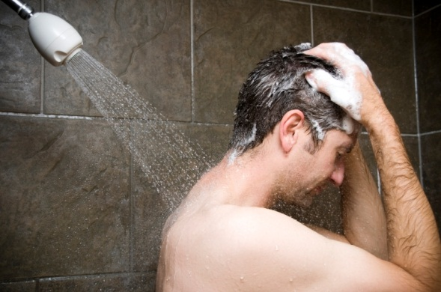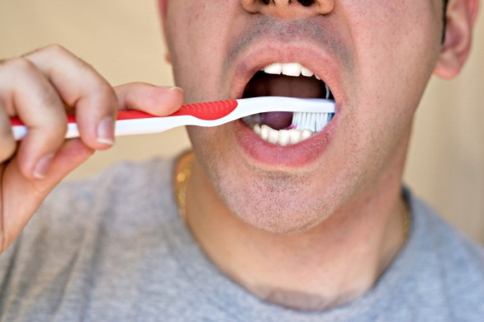

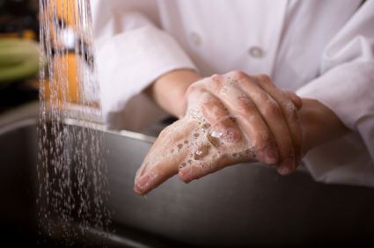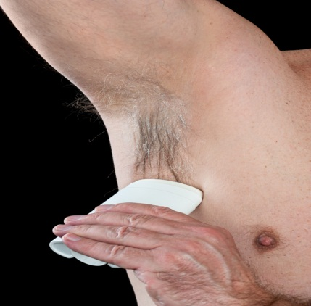

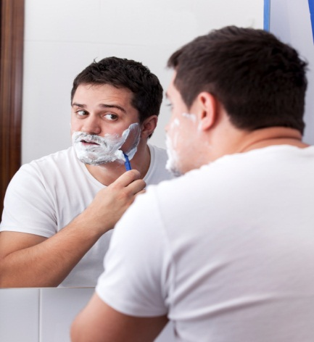

Resource 1: Name the toiletries (version 1 - cut up and match)
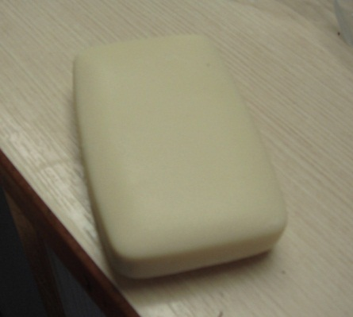 | 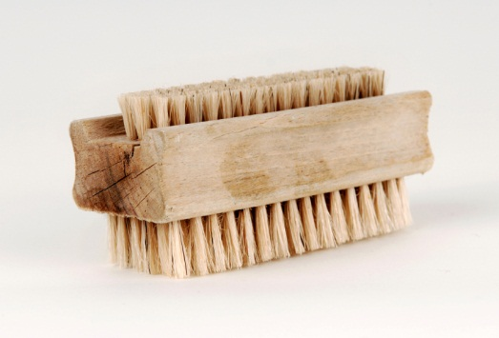
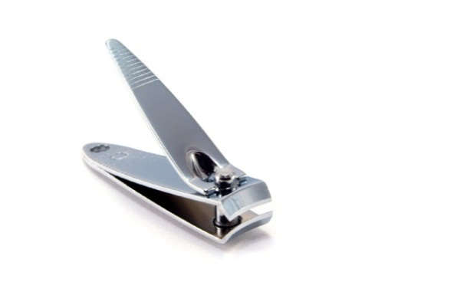 | 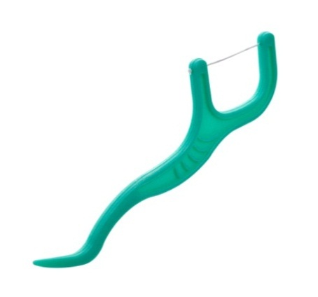
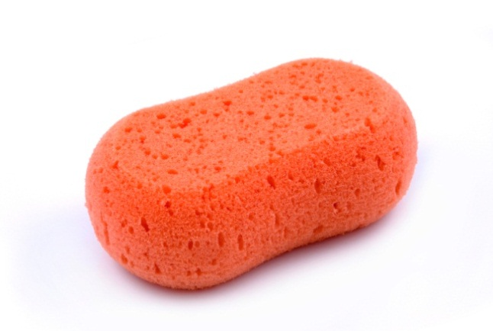 | 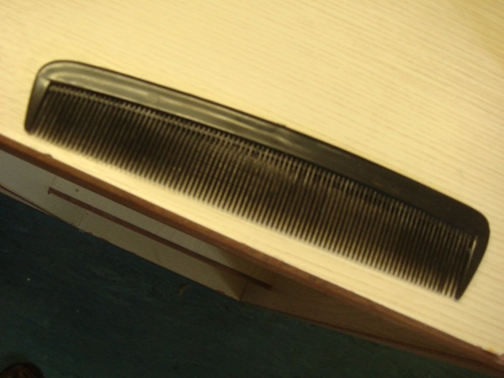
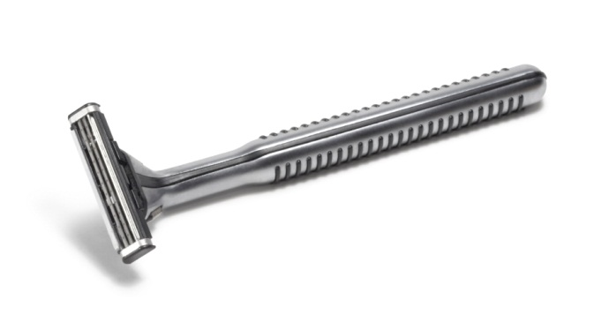 | 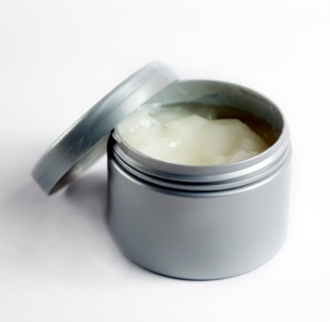
 | 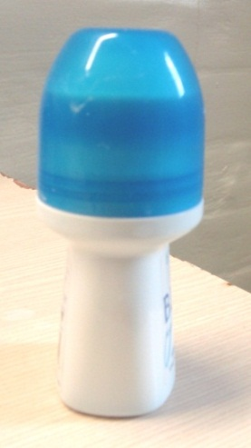
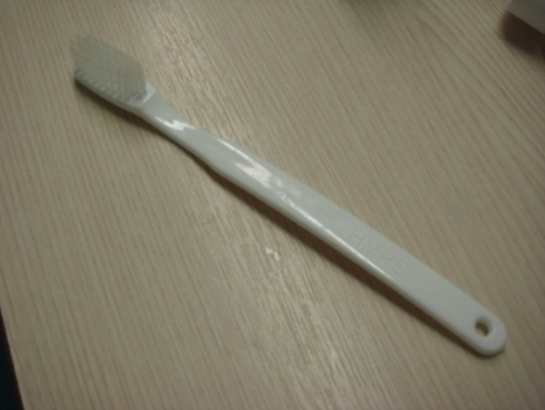 | 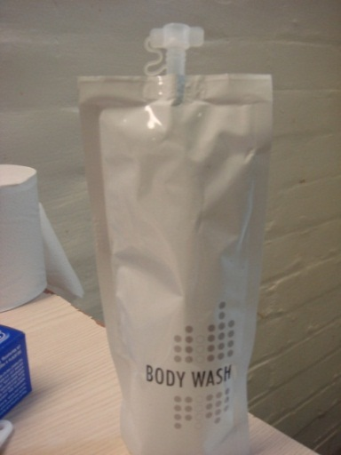
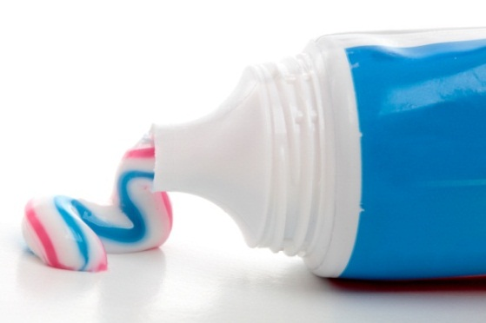 | 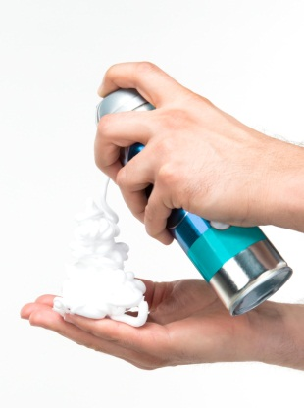

razor | sponge
nail clippers | hair gel
nail brush | hair comb
toothbrush | dental floss pick
roll on deodorant mouthwash | mouthwash
toothpaste | shaving foam
soap | body wash

Resource 1: Name the toiletries (version 2 - label)

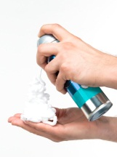 | 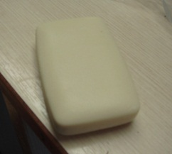 | 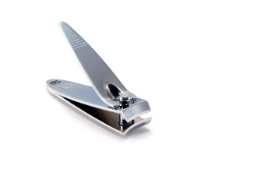
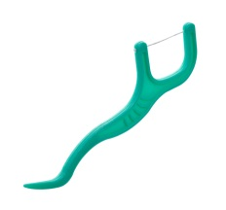 | 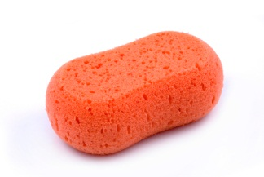 | 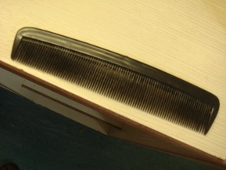
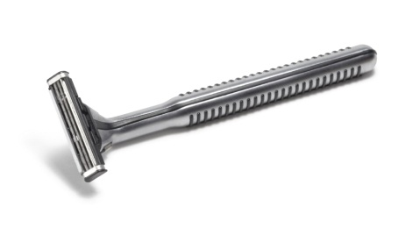 | 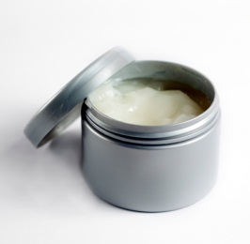 | 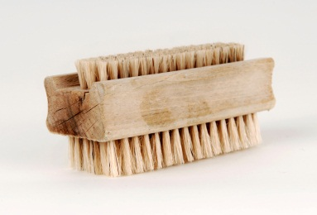
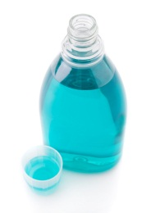 | 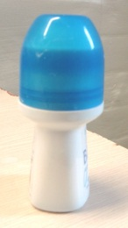 | 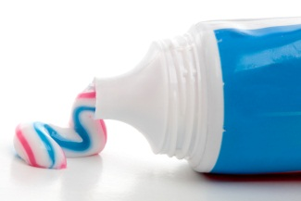
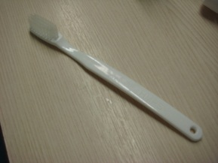 | 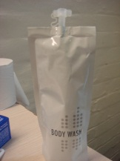

Resource 2: Vocabulary

Look at the order sheet. Write the toiletries in the right box: teeth, body, hair, other

teeth | body
toothbrush

hair | other

Resource 3: Listening – ordering toiletries
- Here are the toiletries from a prison order sheet. Listen to Ravi talking about his order. Tick the items he wants.
Price | Toiletries | Order reference |  | Price | Toiletries | Order reference
£0.65 | soap (pack of 2) | T05281 |  | £2.50 | whitening toothpaste | T08432
£1.29 | shower gel | T06242 |  | £1.50 | budget razor  with 3 blades | T06777
£0.90 | roll on deodorant | T05139 |  | £0.90 | shaving foam | T06321
£1.00 | shampoo | T07230 |  | £1.20 | nail clippers | T08121
£1.05 | conditioner | T06240 |  | £0.90 | nail brush | T09111
£1.50 | afro shampoo/  conditioner | T07159 |  | £1.20 | toothbrush | T06432
£1.00 | hair gel 250ml | T06892 |  | £0.50 | large sponge | T07842
£1.60 | dental floss picks (x30) | T07110 |  | £1.30 | mint mouthwash 500ml | T02167
£1.90 | toothpaste 100ml | T09532 |  | £0.40 | hair comb | T08724

Listen again and answer the questions.

True or false?
- Ravi saves £12 a week in prison.
- Ravi thinks it is important to keep clean.
- Ravi’s dentist told him to use mouthwash.
Write an answer.
- Why does he send things home? ____________________________________________

- How does he feel if he does not have a shower? ________________________________

- Why does he need a nail brush? _____________________________________________

Resource 4: Grammar – adverbs of frequency
Always, usually, sometimes, hardly ever and never are called adverbs of frequency.
Where do we put these words? Do they go before or after the verb?
deodorant.
buy
usually
I

deodorant.
buy
usually
don’t
I

tired.
always
am
I

Activity 4a: Put the words into the sentence.

- I buy hair gel. (never)

- I am too depressed to shave. (sometimes)

- I don’t buy whitening toothpaste. (usually)

Activity 4b: Put the words in order.
- mouthwash / I / some / sometimes / buy
_______________________________________
- always / I / have / a / day / every / shower
_______________________________________
- I / visitor / when / shave / I / have / a / usually
_______________________________________
- hardly / I / teeth / ever / my / floss
_______________________________________

Activity 4c: Make sentences about yourself.

For example: I usually brush my teeth twice a day.

Resource 5: My routine in prison

once/twice  How often do you...?  three times | a | day  week  month  year

Write the question in each box. Use ‘How often do you...?’
Write your answers.
Question – How often do you...? | Answer
have / shower  How often do you have a shower? | I have a shower once a day.
wash / hair

shave

brush / teeth

floss / teeth

wash / clothes

Make more How often questions about prison life (e.g. phone, write). Then write your answers.

Unit 1 Health and hygiene in prison: answers

Warmer
He’s having a shower. He’s brushing his teeth.
He’s washing his hands. He’s having a shave.
He’s flossing his teeth. He’s using deodorant.

Activity 1
soap nail brush
nail clippers dental floss pick
sponge hair comb
razor hair gel
mouthwash roll on deodorant
toothbrush shower gel
toothpaste shaving foam

Activity 2
Teeth | body
- toothbrush  - dental floss picks  - toothpaste  - whitening toothpaste  - mint mouthwash | - shower gel  - soap  - roll on deodorant  - large sponge
Hair | other
- shampoo  - conditioner  - afro shampoo/conditioner  - hair gel  - hair comb | - budget razor  - shaving gel  - nail clippers  - nail brush

Activity 3
- The following were mentioned by Ravi.
roll on deodorant dental floss picks
budget razor with 3 blades nail brush
mint mouthwash 500ml
- False
- True
- True
- To show he’s thinking of his family
- More depressed
- His neighbour took it.

Activity 4
4a  - I never buy hair gel.  - I am sometimes too depressed to shave.  - I don’t usually buy whitening toothpaste. | 4b  - I sometimes buy some mouthwash.  - I always have a shower every day.  - I usually shave when I have a shower.  - I hardly ever floss my teeth.

Activity 5

How often do you have a shower?
How often do you wash your hair?
How often do you shave? / have a shave?
How often do you brush your teeth?
How often do you floss your teeth?
How often do you wash your clothes?
How often do you phone your family?
How often do you write to your family?
How often do you read?

Check learners’ personal answers to these questions.

Unit 1 Health and hygiene in prison: transcript
Activity 3
Ravi’s order
I only earn about £12 a week so it’s really hard to save – nearly impossible. Sometimes I want to send things to my family...you know, to show them I’m thinking about them.
But I think the toiletries are really important …‘cos when I keep clean I feel better. When I’m depressed I don’t want to have a shower - but then I feel more depressed because I know I look bad. Lately I’ve been trying to have a shower every day.
When I fill in the order sheet, I usually try to think of what I will need for the whole month too. This week, I’m gonna buy a new razor. I need a nail brush too. I gave mine to my neighbour – he does a lot of gardening - but he’s gone to a different prison and I think he took it.
It’s been hot in here the last few days so I’m going to need deodorant. Roll-on – we aren’t allowed spray cans in here.
I wanna buy some mouthwash this week too. I don’t usually buy it but the dentist says I gotta. My teeth are getting bad. Oh yeah, he also said I need to start flossing my teeth. So, I’ll get some dental floss picks too. I need more things but I think that’s all I can afford this week.

